The Report on Launching of Maria Mahlzeit Project -Germany

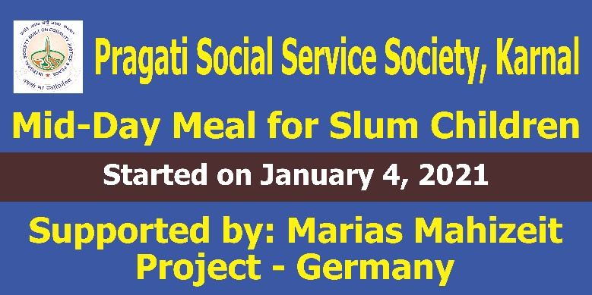
The Pragati Social Service Society (PSSS) is glad to announce that Maria Mahlzeit Project- Germany is launched successfully on January 4, 2021. The PSSS is, indeed, grateful to all the benefactors and specially to Frs. Sharat, Jaisheel and Andrew IMS for their initiatives and timely support and encouragement to launch Maria Mahlzeit Project - Germany in Karnal, Haryana, India.

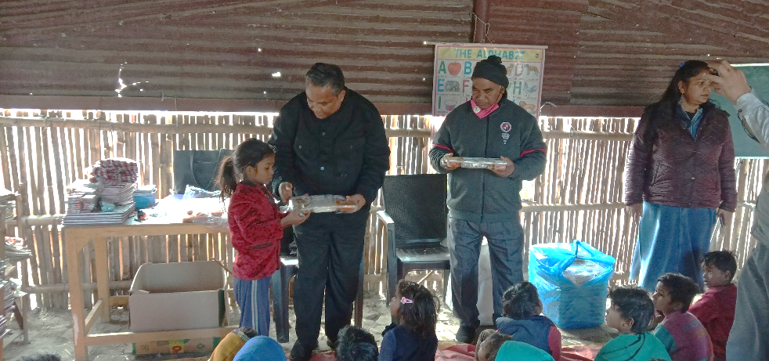
Fr. Ashwin IMS, the President of the organization, inaugurated this event in the presence of the Director, Treasurer, Teachers and slum children numbering almost 100. Children were excited the moment they were informed regarding food distribution weekly.

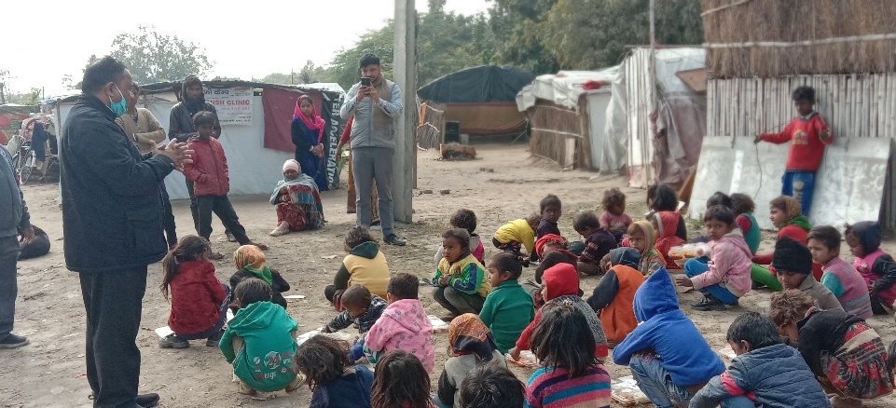
The President, in his address, encouraged the slum children to come for classes regularly. He also informed that this education and Mid-Day Meal support is from those people who want good of slum children. They were happy to hear so.

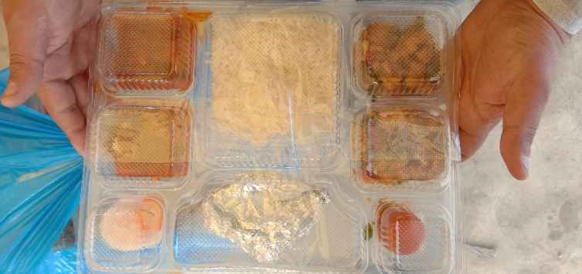
Children are provided nutritious and wholesome Mid-Day Meal every Monday of the week. The food is prepared with much care and love. The food contains Chappati, Rice, egg, Paneer (Indian Cottage Cheese), Pulses, vegetables, Salad and sweets. The food is provided at the centre once their class hour is over.

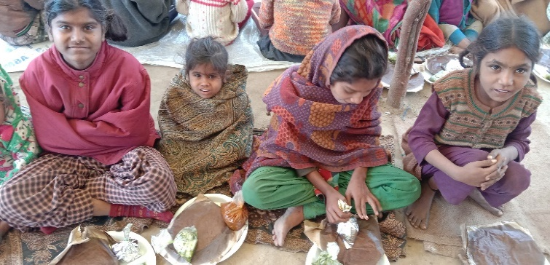
These children of slums are very poor. They rarely get full stomach food. They are migrants from other states of India. Their parents quite often migrate to Haryana and Punjab and other parts of North India in search of work. They are nomadic people. The children we are looking after they are from Rajasthan and Bihar in majority in Karnal slums.
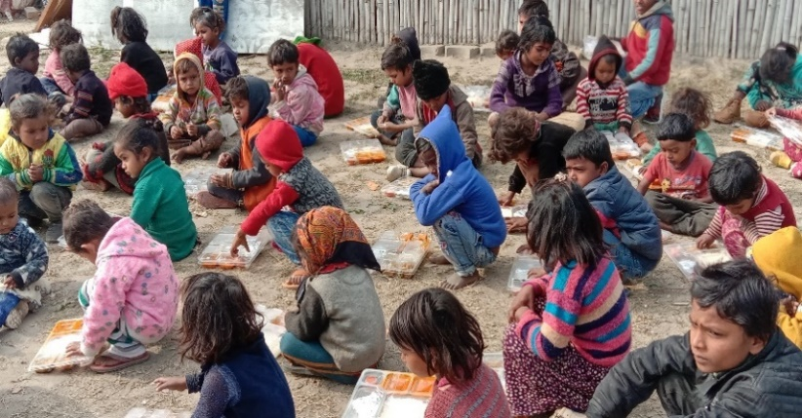
Children are very happy. Parents are also happy seeing their children are given full stomach meal at least once in a week. Mid-Day Meal, indeed, is playing a great role of incentive and encouragement in the life of slum children. They are regular for classes. They are quick in learning and grasping now. They are showing so much interest in the classes. These centres give them non-formal education. Children are benefitting a lot. Teachers are also very committed in teaching and training the students.

Once again, I thank you all wholeheartedly on behalf of slum children and the PSSS for your kind gestures in reaching out to uplift these underprivileged children. We assure you our prayers and promise to keep you updated with the progress time to time.

Yours in Jesus Christ,
Fr. Sandeep Masih IMS,
Treasurer, PSSS
ITI Chowk, Karnal-132001
Haryana, India.
21/01/2021

